Together with their families
Riyansh
Revti & Rajesh Mathur
&
Avni
Darshana & Shashikant Sutar
June
29
2018
WEDDING
Muhurat at 5:30 pm
followed by Dinner
At
The Hellenic Function Centre
31 Crombie Avenue, Bundall QLD 4217
LOGOS/SYMBOLS IN THE DOCUMENT CAN BE CHANGED (IF REQUIRED) TO THE LOGOS/SYMBOLS CHOSEN FROM OUR LIBRARY. CLICK HERE TO BROWSE OUR LIBRARY OF LOGOS/SYMBOLS.

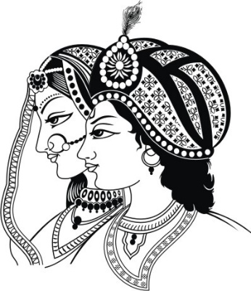
Together with their families
Riyansh
Revti & Rajesh Mathur
&
Avni
Darshana & Shashikant Sutar
RECEPTION
June
30
2018
Ceremony - 7:30 pm
followed by Dinner & Cocktails
At
The Hellenic Function Centre
31 Crombie Avenue, Bundall QLD 4217
LOGOS/SYMBOLS IN THE DOCUMENT CAN BE CHANGED (IF REQUIRED) TO THE LOGOS/SYMBOLS CHOSEN FROM OUR LIBRARY. CLICK HERE TO BROWSE OUR LIBRARY OF LOGOS/SYMBOLS.

